**PRACTICAL 1**

Aim: To implement DDA algorithms for drawing a line segment between two given end

points.

Objective: Draw the line using (vector) generation algorithms which determine the pixels

that should be turned ON are called as digital differential analyzer (DDA).It is one of the

techniques for obtaining a rasterized straight line. This algorithm can be used to draw the line

in all the quadrants.

Theory:

DDA algorithm is an incremental scan conversion method. Here we perform calculations at

each step using the results from the preceding step. The characteristic of the DDA algorithm

is to take unit steps along one coordinate and compute the corresponding values along the

other coordinate. Digital Differential Analyzer (DDA) algorithm is the simple line generation

algorithm which is explained step by step here.

Algorithm:

Step 1: Read end points of the line as (x1, y1) &amp; (x2, y2) such that x1 != x2 and y1 != y2

Step 2: Calculate dx = x2 – x1 and dy = y2 – y1

Step 3: if (dx &gt;= dy)

step = dx

else

step = dy

Step 4: xin = dx / step &amp; yin = dy / step

Step 5: x = x1 + 0.5 &amp; y = y1 + 0.5

Step 6: for (i = 0; i &lt; step; i++)

{

x = x + xin

y = y + yin

putpixel (x, y)

}

Program: #include<iostream.h>

#include<conio.h>

#include<graphics.h>

#include<math.h>

#include<dos.h>

void main()

{

int gd=DETECT,gm;

int x1,y1,x2,y2,xinc,yinc,steps,dx,dy;

initgraph(&gd,&gm,"c:\\turboc3\\bgi");

cout<<"Enter the values of x1 and y1"<<endl;

cin>>x1>>y1;

cout<<"Enter the values of x2 and y2"<<endl;

cin>>x2>>y2;

dx=x2-x1;

dy=y2-y1;

if(abs(dx) > abs(dy))

steps=abs(dx);

else

steps=abs(dy);

xinc=dx/steps;

yinc=dy/steps;

for(int i=0;i<steps;i++);

{

putpixel(x1,y1,2);

x1=x1+xinc;

y1=y1+yinc;

delay(50);

}

getch();

closegraph();

}

Output: 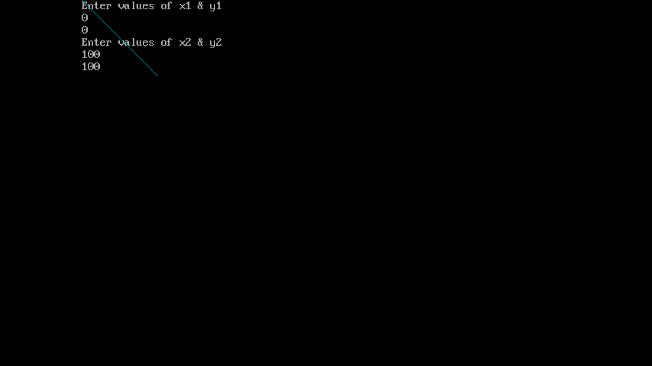

Conclusion: Comment on -

1. Pixel : These algorithms operate at the pixel level, efficiently determining which pixels to activate to create the illusion of a continuous straight line.

2. Equation for line: y = mx+c

3. Need of line drawing algorithm: The efficiency and accuracy of line drawing algorithms are crucial factors in achieving real-time rendering and smooth visual experiences.

4. Slow or fast: Fast